How to install cURL on a Windows environment

- Download CURL from https://curl.se/dlwiz/?type=bin
- Select Operating System

- On select for what flavor select Generic
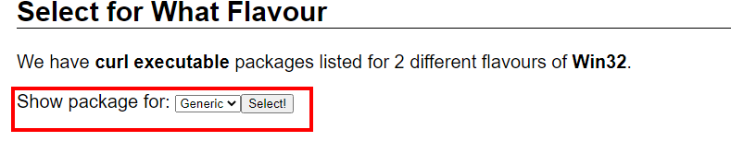
- Click the first installer, whatever the latest CURL version is click the download button
- Under Package click either 32 bit or 64 bit
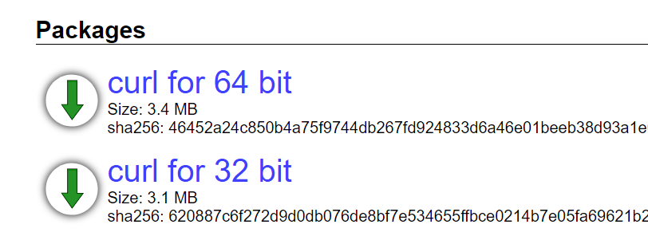
- Once the curl-7.73.0_1-win32-mingw.zip or curl-7.73.0_1-win64-mingw.zip is downloaded, extract content
- Launch Command Prompt as Administrator

- Within Command Prompt browse to bin directory of the extracted curl zip file
For example: C:\Users\Administrator\Desktop\curl-7.73.0_1-win32-mingw\curl-7.73.0-win32-mingw\bin
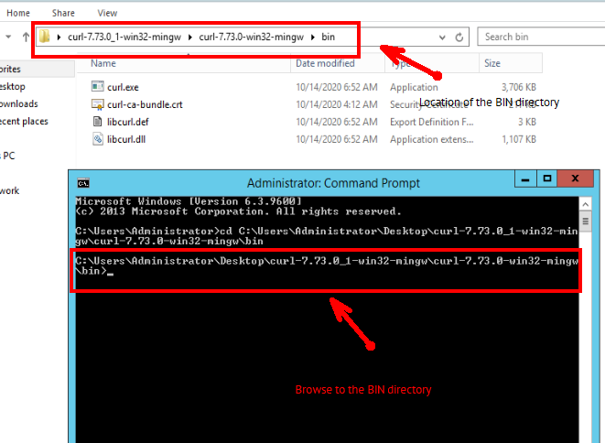

See Knowledge Base article on How to run cURL with DocConverter

